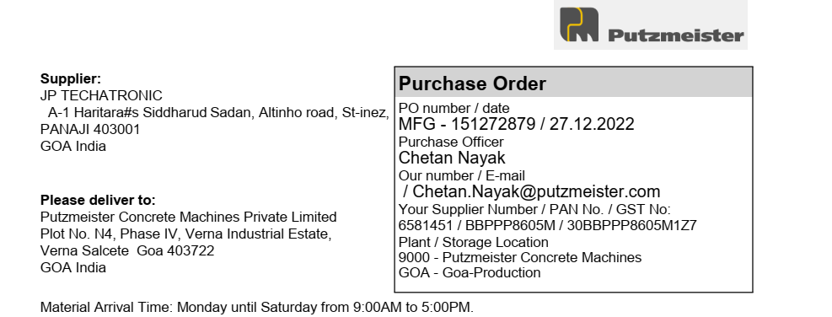

|  |  |  |  |  |  |  |
| --- | --- | --- | --- | --- | --- | --- |
| **Sr. No** | **Material** | **Description** | **Quantity** | **Unit** | **Price Per Unit** | **Net Price (INR)** |
| 1 | 719381 | Monochrome  laserjet printer CanonLBP6030BJ | 10 | PCS | 8299 | 82990 |
|  |  |  |  | CGST | 9% | 7469.1 |
|  |  |  |  | SGST | 9% | 7469.1 |
| Delivery Schedule |  |  |  |  | |  |
| Date | 16.01.2023 |  |  | Basic Total | | 97928.2 |
|  |  |  |  | Central GST | | 7469.1 |
|  |  |  |  | State GST | | 7469.1 |
|  |  |  |  | **Total In INR** | | **112866.4** |

Amount In Words:

One Lakh Twelve Thousand Eight Hundred Sixty Six Rupees Forty Paise.

Send Original/Duplicate/Invoice along with material.

If non excisable material – TAX invoice – 2 copy in original.

If material is received without the required documents and details, it will not be received in the plant.

Confirmation of this order should be within 5 days.

It is necessary to put the Putzmeister order number on every invoice.

Terms and conditions applied.



